**How to Register for an Erie 1 BOCES WR Activity   
Frontline Professional Learning Management**

1. If you have a link to a specific activity, click the link to view activity details and click Enroll.

**Select a Log in Method**

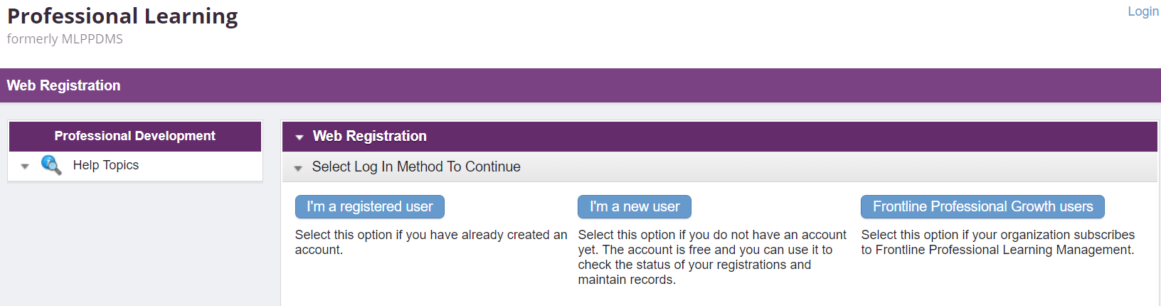

1. If you have never registered with Erie 1 BOCES WR, select that you are a new user.   
     
   Enter your first and last name, district email address (not your personal) and you’ve created an account. There will be a form to set your password and more required information. Fields outlined in red are mandatory. Click Create Account at the bottom.

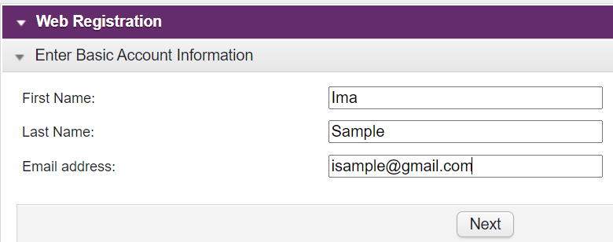

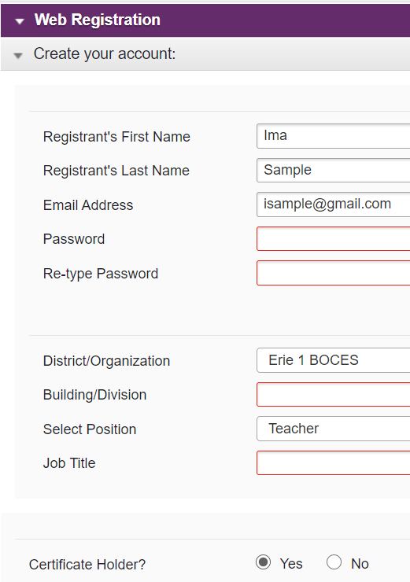 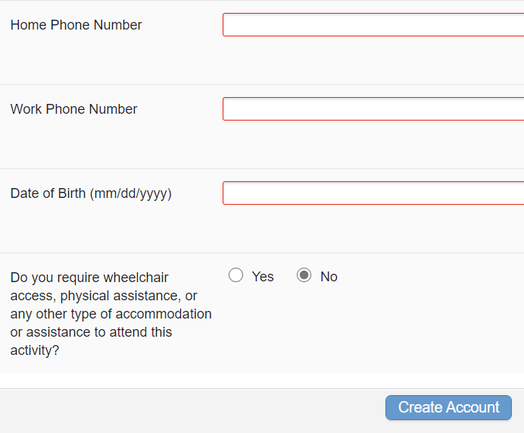

Note: If you receive a message that your email address has an existing account, your district may already have a Frontline account for you. Log in as a registered user (see below).

1. If you have previously registered with Erie 1 BOCES WR, you are a registered user. If your district uses Frontline, you also are a registered user. However, before logging in here, make sure you are logged out of your district Frontline account.



Click here to log in. Update your account information if needed, click update and continue at the bottom. If you experience problems logging in, contact [pgsupport@frontlineed.com](mailto:pgsupport@frontlineed.com) or call 1-866-504-8222

1. Fill in the required information on the registration form, click the checkmark agreeing to the terms and conditions, click Submit.
2. You will receive an email confirming that you have registered, and it will include details of the activity.
3. **Viewing your registrations and obtaining CTLE certificates**
4. Go to <https://www.frontlineeducation.com/pg-login> and log in.
5. Your registrations will show under My Registrations. Click the title to view activity details.
6. 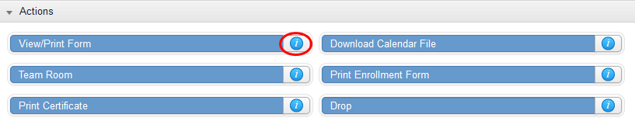Scroll to the bottom for Actions. Float your curser on the i for more information, especially if you need to drop the activity. For many, you will not be able to drop yourself and there will be contact information listed.

Select this to print your CTLE certificate.

Please contact Mansel Wells at [mwells@e1b.org](mailto:mwells@e1b.org) if you are having problems.